Regenerative action cycle

What is it?
This model is based on the observation of natural cycles as well as teachings from many regenerative cultures and indigenous cultures around the world.

Why do we need it?
It draws out ways we can follow these cycles in our human activities to foster connection and regeneration within ourselves, within our communities and in our relationship with the other-than-human communities we are part of.

How do we achieve it?
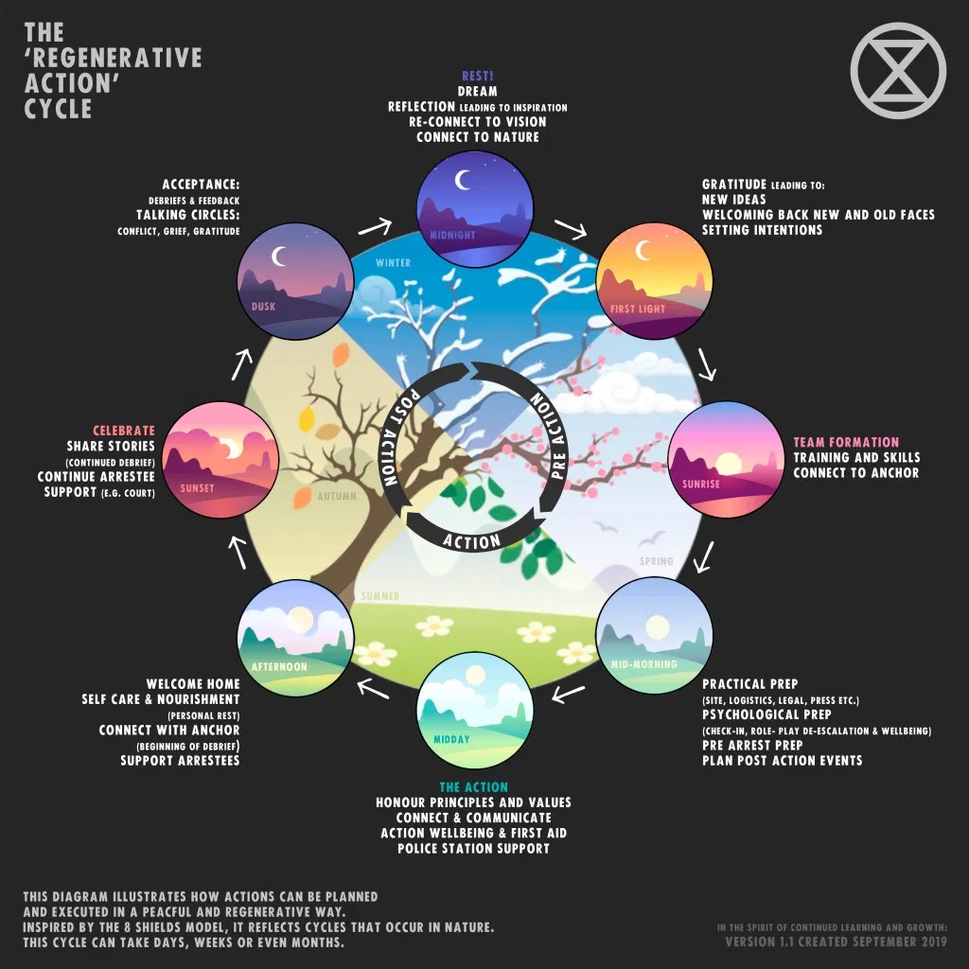
Follow the steps!

